**ASSIGNMENT 3**

**MSIS 2603 – Database Management System**

Consider the following relational database schema

**RESIDES (PERSON_NAME, STREET, CITY, STATE, ZIP)**

**WORKS (PERSON_NAME, COMPANY_NAME, SALARY)**

**ADDRESS (COMPANY_NAME, CITY, STATE, ZIP)**

**MANAGES (PERSON_NAME, MANAGER_NAME)**

Populate each of these tables using the queries in file [Assignment 3 - Database Setup Queries.sqlView in a new window](https://camino.instructure.com/courses/17800/files/775260/download?wrap=1) to help you test your queries below

For each table select all rows and include them in your submission as follows:

1. SELECT*

FROM RESIDES

**RESIDES**

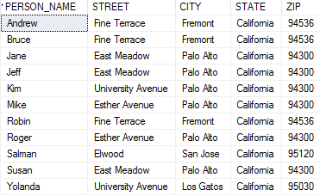

1. SELECT*

FROM WORKS

**WORKS**

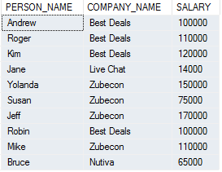

1. SELECT*

FROM ADDRESS

**ADDRESS**

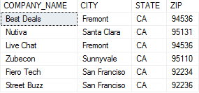

1. SELECT*

FROM MANAGES

**MANAGES**

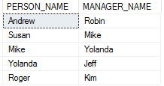

Construct a SQL for each of the queries below and show the results of executing your queries:

1. Find the name, zip code of all employees who work for 'Best Deals' (2 pts)

SELECT R.PERSON_NAME, R.ZIP

FROM RESIDES R, WORKS W

WHERE COMPANY_NAME = 'Best Deals' AND R.PERSON_NAME = W.PERSON_NAME

**Result:**

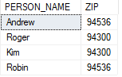

1. Find name & company name of employees who live in the same zip code as the company they work for (2 pts)

SELECT DISTINCT R.PERSON_NAME, W.COMPANY_NAME

FROM RESIDES R, WORKS W, ADDRESS A

WHERE R.PERSON_NAME = W.PERSON_NAME AND R.ZIP = A.ZIP AND W.COMPANY_NAME = A.COMPANY_NAME

**Result:**



1. Find name, street name & city of employees who live in the same city and street as their manager (3 pts)

SELECT M.PERSON_NAME, R1.STREET, R1.CITY

FROM RESIDES R1, RESIDES R2, MANAGES M

WHERE R1.PERSON_NAME = M.PERSON_NAME AND R2.PERSON_NAME = M.MANAGER_NAME AND R1.STREET = R2.STREET AND R1.CITY = R2.CITY

**Result:**



1. Find all persons who do not work for any company (3 pts)

SELECT R.PERSON_NAME

FROM RESIDES R

EXCEPT

SELECT W.PERSON_NAME

FROM WORKS W

**Result:**



1. Find the number of employees for each of the managers (2 pts)

SELECT COUNT(*) AS 'Number of Employees', M.MANAGER_NAME

FROM MANAGES M

GROUP BY M.MANAGER_NAME

**Result:**

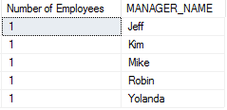

1. Give all managers of ‘Zubecon’ a 10 percent raise, unless their salary becomes greater than $120,000. In such cases, give only a 4% raise. (5 pts)

UPDATE WORKS SET WORKS.SALARY = 1.04*(WORKS.SALARY)

FROM WORKS, MANAGES

WHERE WORKS.PERSON_NAME = MANAGES.MANAGER_NAME AND WORKS.SALARY * 1.1 > 120000 AND WORKS.COMPANY_NAME = 'Zubecon'

**Result:**

(3 row(s) affected)

UPDATE WORKS SET WORKS.SALARY = 1.1*(WORKS.SALARY)

FROM WORKS, MANAGES

WHERE WORKS.PERSON_NAME = MANAGES.MANAGER_NAME AND WORKS.SALARY * 1.1 <= 120000 AND WORKS.COMPANY_NAME = 'Zubecon'

**Result:**

(0 row(s) affected)

1. Layoff all employees of ‘Zubecon’ (3 pts)

DELETE MANAGES FROM MANAGES INNER JOIN WORKS ON MANAGES.PERSON_NAME = WORKS.PERSON_NAME WHERE WORKS.COMPANY_NAME = 'Zubecon'

**Result:**

(3 row(s) affected)

DELETE FROM WORKS WHERE WORKS.COMPANY_NAME = 'Zubecon'

**Result:**

(4 row(s) affected)

1. Company ‘Fiero Tech’ is moving to Pleasanton, California, 94558. Update its address. (2 pts)

UPDATE ADDRESS

SET ADDRESS.CITY = 'Pleasanton', ADDRESS.STATE = 'California', ADDRESS.ZIP = '94558'

WHERE COMPANY_NAME = 'Fiero Tech'

**Result:**

(1 row(s) affected)

1. John Reid lives on 34278 Eucalyptus Drive in Fremont, California 94536. He is joining ‘Street Buzz’ and will be working for Susan at a salary of $120,000. Assume that all information about Susan is already present in the database and that no information about John Reid is in the database. Perform all database updates. (4 pts)

INSERT INTO RESIDES(PERSON_NAME,STREET,CITY,STATE,ZIP)

VALUES ('John Reid','34278 Eucalyptus Drive','Fremont','California', 94536)

**Result:**

(1 row(s) affected)

INSERT INTO WORKS(PERSON_NAME,COMPANY_NAME,SALARY)

VALUES ('John Reid','Street Buzz', 120000)

**Result:**

(1 row(s) affected)

INSERT INTO MANAGES (PERSON_NAME,MANAGER_NAME)

VALUES ('John Reid','Susan')

**Result:**

(1 row(s) affected)

1. Give all employees of 'Best Deals' a salary raise of 15% and then compute the sum of salaries for Best Deals employees (4 pts)

UPDATE WORKS SET SALARY = 1.15*(SALARY)

WHERE WORKS.COMPANY_NAME = 'Best Deals'

**Result:**

(4 row(s) affected)

SELECT SUM(SALARY) AS 'TOTAL SALARIES OF BEST DEAL EMPLOYEES'

FROM WORKS

WHERE COMPANY_NAME = 'Best Deals'

**Result:**

